**CHAPTER I**

**INTRODUCTION**

Dengue is an acute viral disease in tropics and subtropics like India, Egypt, Pakistan, West Indies and Indonesia. It is the most significant health problem in tropics. The septic disease dengue is transferred by the mosquito. The infants, young children, and adults are affected through this fatal disease. The signs and indications of dengue are seen between 3-14 days after the insect bite. There has been a global increase in the morbidity rate of dengue fever, dengue haemorrhagic fever, and its epidemics in last two decades. It is not easy to diagnose it. Dengue has the same symptoms like other viral infections such as fever, headache, vomiting, etc. This factor has become a difficult for doctors to diagnose the exact illness. These variables induce some imprecision and uncertainties in diagnosing the disease. Therefore, diagnosing the disease is a critical issue due to enormous variables involved in a process.

**1.1 SOFT COMPUTING**

Traditional mathematics cannot deal with diagnosing the disease as it also yields various types of uncertainties. Subsequently, the question arises what method should be adopted to address such issues? Expert systems are helpful in eliminating uncertainty and imprecision [6]. Intelligent systems are playing a significant role in solving many challenging human problems. An expert system is a smart computer program that solves the problem using the knowledge base of experts and different procedures. Human experts find the solution of the issues with the help of facts and “reasoning ability”. It is presumed that an expert system, consist of two factors which are related to components: named as knowledge base and technique base system which enables the expert system to conclude. Soft computing technology has been a subject of research in computational sciences. Several techniques in soft computing such as ESs, neural networks, fuzzy logic, genetic algorithm, Bayesian statistics, Khaos theory, etc. have been developed and implemented to resolve many issues and make possible to diagnosed different diseases in the field of medicine and engineering design. In recent years some new techniques have been introduced to solve the substantial issues efficiently. These new techniques are involved with intuitionistic fuzzy soft sets, probability, vague sets, fuzzy set theory, the theory of interval mathematics, rough set theory, etc. These theories could be used as practical tools which proposed to handle the diverse sorts of uncertainties and deception n experienced in a problem.

In 1965, to deal with the chal lenges of vagueness, L. A. Zadeh [10] introduced the theoretical approach known as "fuzzy set theory". The application of “fuzzy set theory” to medical diagnosis of dengue fever discussed in. In this study, the choice of fuzzy logic is because it resembles with the human decision-making abilities. Later on, researchers observed some drawbacks of “fuzzy set theory” because there are different types of affiliation functions in “fuzzy set theory” and the accuracy level of each membership is different. In fact, all approaches are linked with an inherent restraint, this shows the insufficiency of the “parameterization tool” related to these theories. Therefore, a method was needed to eliminate such kind of flaws. The solution to problem of the parameterization tool has led the researchers to seek out possible ways. Molodtsov (1999) demonstrated the idea of “soft set theory” as a new tool which functions according to mathematical rules to cope with an environment of imprecision [4]. The “soft set theory” allows the object to be defined without any hard and fast rules. Recently the establishment and development of soft set theory, augmented its applications in numerous fields.

In this study, fuzzy set theory and soft set theory is used to diagnose dengue fever. The fuzzy set theory was constructive in the field of medical, engineering and economics. However, the actual challenge is how to choose a membership function to obtain significant results. The fuzzy set theory has various membership functions, and all of them have variations in accuracy which made it crucial to choose a membership function. The soft set theory does not require any additional parameterization tool because it is a parameterized theory.

**1.2 REVIEW OF LITERATURE**

Artificial intelligent systems apply to address medical issues such as "dengue fever." Researchers make efforts on medical expert systems to find the solution to medical problems [8]. The diagnosis of tropical diseases involves different levels of imprecision and ambiguity. In 1999 Molodtsov [4] put forward the idea of “Soft set theory”. It is a tool of the mathematical field to deal with an environment of imprecision which is very easy to use and the absence of difficulties can be observed in “fuzzy set theory”. The soft set theory has several applications in different fields. The soft set is a set linked with a “set of parameters” and the application is observed in different directions. In “fuzzy set theory” to identify the membership function, some parameters are needed. The” soft set theory” allows the object to be defined without any hard and fast rules. The “soft set theory” is normally linked with further mathematical methods. Some operations on soft set theory have been discussed [5], but this research exhibited some drawbacks. Subsequently, Boullart et.al [6] shed light on these drawbacks that were associated with the theory. For example, equality form of two soft sets, in the form of a complement of a soft set, null soft set as well as in the form of a superset of a soft set, etc. In soft set theory, De Morgan's laws, binary operations like union, intersection, AND, OR, and NOR were also introduced.

Chen et .al [2] discussed how to reduce parameters and highlighted the applications of soft sets. Y. Zou and Z. Xiao initiated the study on soft sets under incomplete information. They put forward improved data analysis approaches for standard soft sets and fuzzy soft sets under incomplete information, respectively. They verified it with the help of an example to measure the performance of the algorithms used, Finally, they presented a technique for the parameter reduction of “soft sets” and deeply studied the algebraic structure of the “soft set theory” to deal with uncertainty and imprecision. Maaz Amjad et al. [3] discussed a soft expert system and fuzzy set theory to diagnose dengue fever and find out the exact percentage risk of dengue fever.

In this study, discussions made on soft rules system to avoid the difficulty in the selection of the membership function. Objective is how soft-set theory can be utilized in medicine. The soft set theory is a parameterized method that does not require any parameter. The role of an expert organization is to develop improved practitioner performance and ultimately patient outcomes. As a result, of this the standard of health care improved.

**1.3 OBJECTIVE**

The main objective of this study is:

* How soft set theory can be used to develop a knowledge-based medicine system.
* To device a prediction system named soft expert system (SES) by using the age, TLC, SGOT, platelets count, and blood pressure and calculate the exact percentage of the risk of dengue fever.
* Our recommendation to the Doctor to examine whether the patient needs treatment or not.

**1.4 STATISTICAL SOFTWARE**

All tools pertaining to this study are carried using R Software Packages.

**1.5 R- SOFTWARE**

R is a language and environment for statistical computing and graphics. R is a programming language for statistical computing and graphics supported by the R Core Team and the R Foundation for Statistical Computing. R offers a wide variety of statistics-related libraries and provides a favourable environment for statistical computing and design. In addition, the R programming language gets used by many quantitative analysts as a programming tool since it's useful for data importing and cleaning. Although R is a popular language used by many programmers, it is especially effective when used for

* Data analysis
* Statistical inference
* Machine learning algorithms

**1.6 ORGANIZATION OF THE STUDY**

Further in this study,

Chapter II deals with the research methodology,

Chapter III deals with the discussion of soft set theory approach for dengue fever in framing soft rules and calculating risk percentage of dengue fever and

Chapter IV deals with summary and conclusions.

**CHAPTER II**

**RESEARCH METHODOLOGY**

This study has some important concepts and mathematical tools to work with. This section discusses about them.

**2.1 DENGUE FEVER**

Dengue is a viral infection caused by the dengue virus (DENV), transmitted to humans through the bite of infected mosquitoes.

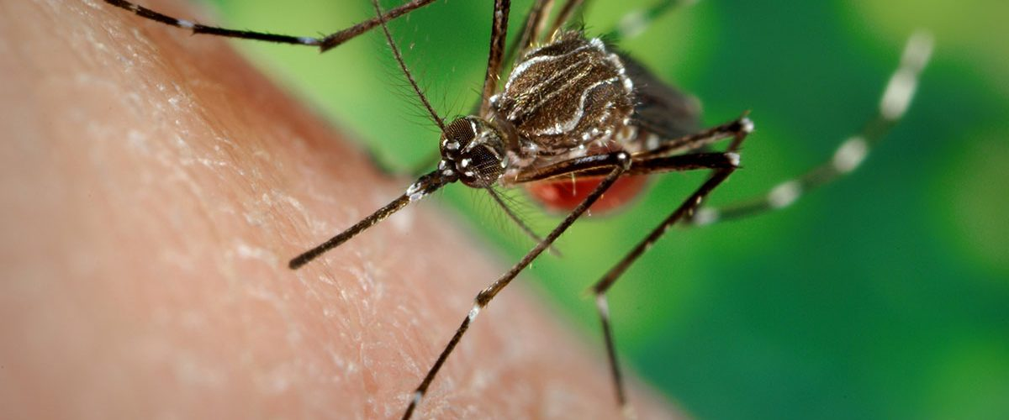

**Fig 2.1 Dengue Mosquito**

It is more common in tropical and subtropical climates. Dengue is treated with pain medicine as there is no specific treatment currently. You can lower your risk of dengue by avoiding mosquito bites especially during the day. Most people who get dengue won’t have symptoms. But for those that do, the most common symptoms are high fever, headache, body aches, nausea and rash. Dengue fever is transmitted through an infected mosquito.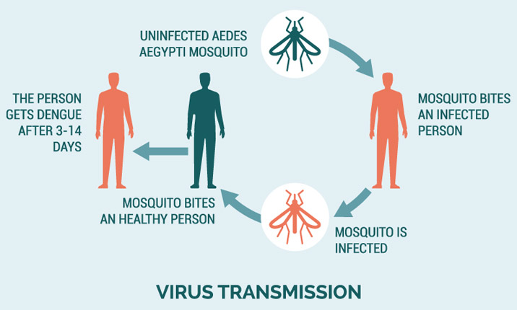

**Fig 2.2 Transmission of Dengue virus**

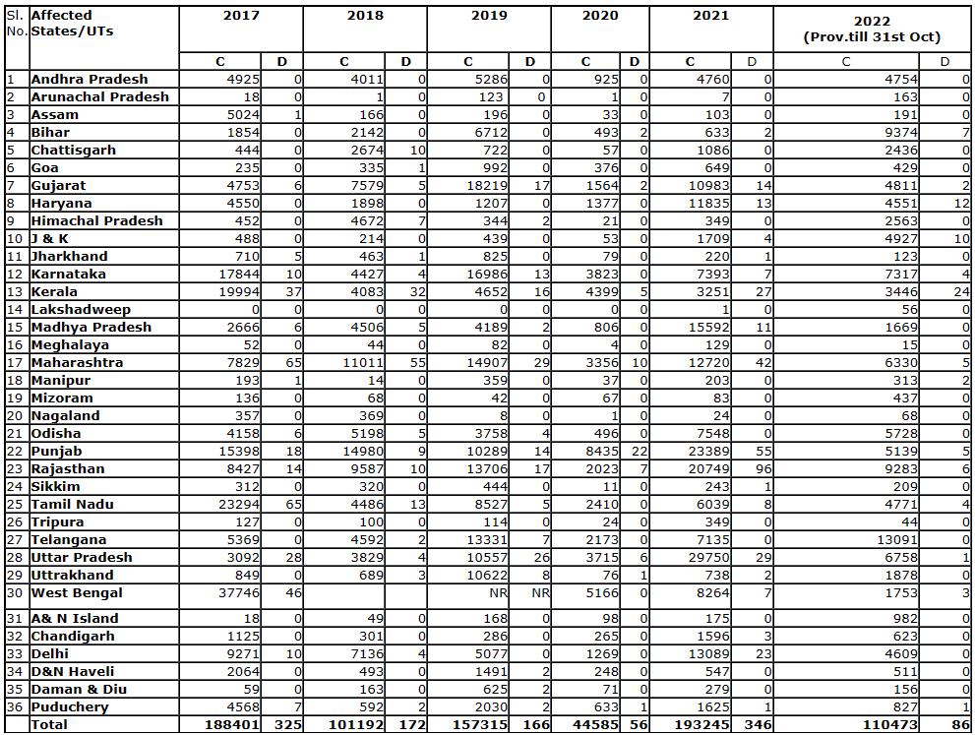The table below shows the state-wise dengue fever outbreak of India, since 2017.

**Table 2.1** **Dengue Cases and Deaths in the Country since 2017**

**2.2 DIAGNOSTIC FACTORS OF DENGUE FEVER**

Dengue fever can be identified with some of the essential factors and their levels.

* Total Leukocyte Count (TLC).
* Serum Glutamic-Oxaloacetic Transaminase (SGOT).
* Platelet Count (PC).

These factors will be helpful to determine whether the patient has dengue fever or not. However along with these factors Age and Blood Pressure is also considered for Dengue fever.

**2.2.1 TOTAL LEUKOCYTE COUNT (TLC)**

Total Leukocyte Count (TLC) test measures the total number of all the leukocytes in the blood. Leukocytes are white-coloured blood cells that defend our bodies against infections and diseases. This test helps determine the body's capacity to fight diseases. The count of TLC indicates its types,

* Leucopenia <4000
* Normal leukocyte range 4,000-11,000
* Leukocytosis >11,000

**2.2.2 SERUM GLUTAMIC-OXALOACETIC TRANSAMINASE (SGOT)**

The SGOT test is a blood test that’s part of a liver profile. It measures one of two liver enzymes called serum glutamic-oxaloacetic transaminase. This enzyme is now usually called Aspartate amino-transferase. SGOT test may be used to help your doctor diagnose liver damage or liver disease. When liver cells are damaged, SGOT leaks into the blood stream, raising your blood’s level of this enzyme. The normal range of an SGOT test is generally between 8 and 45 units per litter of serum. In general, cisgender males may naturally have higher amounts of AST in the blood. A score above 50 for cisgender males and 45 for cisgender females is high and may indicate damage.

**2.2.3 PLATELET COUNT (PC)**

Platelets are the cells that circulate within our blood and bind together when they recognize damaged blood vessels and can only be seen under a microscope. They’re literally shaped like small plates in their non-active form. A blood vessel will send out a signal when it becomes damaged. When platelets receive that signal, they’ll respond by traveling to the area and transforming into their “active” formation.

* Thrombocytopenia <150,000
* Normal Platelet count range 150,000 - 450,000
* Thrombocytosis >450,000

**2.2.4 AGE & BLOOD PRESSURE (BP)**

Blood pressure (BP) measures the force pressed against the walls of your arteries as your heart pumps blood through your body. Average blood pressure differs by sex and tends to rise with age. Blood pressure readings are composed of two numbers—for example, 120/80 mm Hg. Both numbers are an important part of your blood pressure reading. The top number (systolic pressure) measures the pressure in your arteries when your heart beats. The bottom number (diastolic pressure) measures the pressure in your arteries between each heartbeat. As age gets older, blood vessels tend to become stiffer and plaque can build up in them, which can raise blood pressure. If blood pressure becomes too high, there is a greater risk for heart disease, stokes, and more.

|  |  |  |
| --- | --- | --- |
| **Blood Pressure by Age** | | |
| **Age** | **Men** | **Women** |
| **18-39 years** | 119/70 mm Hg | 110/68 mm Hg |
| **40-59 years** | 124/77 mm Hg | 122/74 mm Hg |
| **60+ years** | 133/69 mm Hg | 139/68 mm Hg |

**2.3 SETS AND ITS FUNCTION**

**2.3.1 FUZZY SET**

Let X be a space of points (objects), with a generic element of X denoted by x. Thus, X = {x}. A fuzzy set (class) A in X is characterized by a membership (characteristic) function $f_{A}(x)$ which associates with each point in X. A real number in the interval [0, 1] with the value of $f_{A}(x)$ at x representing the "grade of membership" of x in A. The nearer the value of $f_{A}(x)$ to unity, the higher the grade of membership of x in A.

For example, if Ω is some set, then a fuzzy subset A of Ω is defined by its membership function, written A(x), which produces values in [0, 1] for all x in Ω. So, A(x) is a function mapping Ω into [0, 1]. If A($x_{0}$) = 1, then we say $x_{0}$ belongs to A, if A($x_{1}$) = 0 we say $x_{1}$ does not belong to A, and if A($x_{2}$)=0.6 we say the membership value of $x_{2}$ in A is 0.6. When A(x) is always equal to one or zero we obtain a crisp (non–fuzzy) subset of Ω. For all fuzzy sets B, C, ... we use B(x), C(x), ... for the value of their membership function at x. Most of the fuzzy sets we will be using will be fuzzy numbers.

The term “crisp” will mean not fuzzy. A crisp set is a regular set. A crisp number is just a real number. A crisp matrix (vector) has real numbers as its elements. A crisp function maps real numbers (or real vectors) into real numbers. A crisp solution to a problem is a solution involving crisp sets, crisp numbers, crisp functions, etc.

**2.3.2 FUZZY NUMBERS**

Fuzzy numbers will be almost always triangular (shaped), or trapezoidal (shaped), fuzzy numbers. A triangular fuzzy number N is defined by three numbers a<b<c where the base of the triangle is the interval [a, c] and its vertex is at x = b. Triangular fuzzy numbers will be written as N = (a/b/c). A triangular shaped fuzzy number P is given in Fig 2.1. P is only partially specified by the three numbers 1.2, 2, 2.4 since the graph on [1.2, 2], and [2, 2.4], is not a straight-line segment. To be a triangular shaped fuzzy number one require the graph to be continuous and

* monotonically increasing on [1.2, 2]; and
* monotonically decreasing on [2, 2.4].

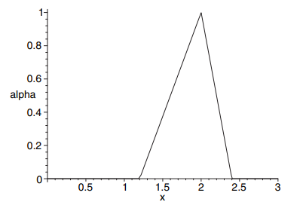For triangular shaped fuzzy number P we use the notation P ≈ (1.2/2/2.4) to show that it is partially defined by the three numbers 1.2, 2, and 2.4. If P ≈ (1.2/2/2.4) we know its base is on the interval [1.2, 2.4] with vertex (membership value one) at x = 2.

**Fig 2.3 Triangular fuzzy number**

A trapezoidal fuzzy number M is defined by four numbers a<b<c<d where the base of the trapezoid is the interval [a, d] and its top (where the membership equals one) is over [b, c]. We write M = (a/b/c/d) for trapezoidal fuzzy numbers.

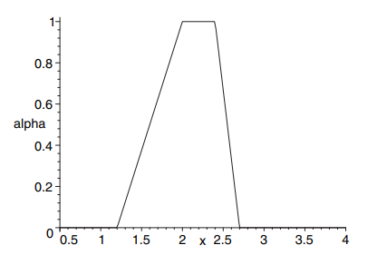Trapezoidal shaped fuzzy number Q ≈ (1.2/2, 2.4/2.7) whose base is [1.2, 2.7] and top is over the interval [2, 2.4]. The graph of Q is in Fig 2.2, it has continuous curves for its sides.

**Fig 2.4 Trapezoidal fuzzy number**

**2.3.3 MEMBERSHIP FUNCTION**

For any set X �XX, a membership function on �XX is any function from �X to the real unit interval [0,1]. Membership functions represents fuzzy subsets of X�. The membership function which represents a fuzzy set �~A is usually denoted by .��. Membership function can be defined for three different set operations.

The membership function $μ_{C}\left(x\right)$ of the intersection $C=A∩B$ is pointwise defined by

$μ_{C}\left(x\right)=\min{\{}μ_{A}\left(x\right),μ_{B}\left(x\right)\} for x∈X$

The membership function $μ_{D}\left(x\right)$ of the union $D=A∪B$ is pointwise defined by

$μ_{D}\left(x\right)=\max{\{}μ_{A}\left(x\right),μ_{B}\left(x\right)\} for x∈X$

The membership function of the complement of a normalized fuzzy set A, is defined by

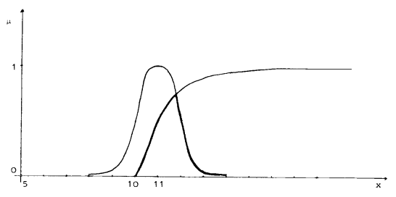 **$μ_{EA}\left(x\right)=1-μ_{A}\left(x\right) for x∈X$**

**Fig 2.5 Union and Intersection of fuzzy sets**

**2.3.4 $α$– CUT**

- cut are slices through a fuzzy set producing regular (non- fuzzy) sets. If A is a fuzzy subset of some set U, then a $α$- cut of A, written A [$α$] is defined as

$$A \left[α\right]=\left\{x ϵ U \right| A\left(x\right)≥ α$$

For all $α$, $0< α≤1$. The $α$ = 0 cut, or A[0], must be defined separately.

The core of a fuzzy number is the set of values where the membership value equals one. If N = (a/b/c), or N ≈ (a/b/c), then the core of N is the single point b. However, if M = (a/b, c/d), or M ≈ (a/b, c/d), then the core of M = [b, c]. For any fuzzy number Q we know that Q[α] is a closed, bounded, interval for 0 ≤ α ≤ 1. We will write this as

Q[α]=[q1(α), q2(α)]

where q1(α) (q2(α)) will be an increasing (decreasing) function of α with q1(1) ≤ q2(1). If Q is a triangular shaped or a trapezoidal shaped fuzzy number then:

* q1(α) will be a continuous, monotonically increasing function of α in [0, 1]
* q2(α) will be a continuous, monotonically decreasing function of α, 0 ≤ α ≤ 1 and
* q1(1) = q2(1) (q1(1) < q2(1) for trapezoids).

We sometimes check monotone increasing (decreasing) by showing that dq1(α)/dα > 0 (dq2(α)/dα < 0) holds.

**2.3.5 SOFT SET**

A pair (F, E) is called a soft set (over U) if and only if F is a mapping of E into the set of all subsets of the set U. In other words, the soft set is a parametrized family of subsets of the set U. Every set F ($ε$), $ε ϵ$ E, from this family may be considered as the set of $ε$ elements of the soft set (F, E), or as the set of $ε$-approximate elements of the soft set.

**2.3.6 OPERATIONS USING SOFT SETS**

1. **COMPLEMENT SOFT SET OF A SOFT SET**. The complement of a soft set (F, A) is denoted by ${(F, A)}^{C}$ and is defined by ${(F, A)}^{C}$ = ${(F}^{C},|A)$ where $F^{C},|A → P(U)$ is a mapping given by $F^{C}(α)= U - F(|α)$, $∀ α ∈A$. Let us call $F^{C}$ to be the soft complement function of F. Clearly ${(F^{C})}^{C}$ is the same as F and ${{((F, A)}^{C})}^{C}= (F, A)$.
2. **NULL SOFT SET**. A soft set (F, A) over U is said to be a null soft set denoted by $Φ$, if $∀ε ϵ A, F\left(ε\right)= ϕ$, (null-set,).
3. **AND OPERATIONON TWO SOFT SETS**. If (F, A) and (G, B) are two soft sets then “(F, A) AND (G, B)” denoted by $(F, A) ∧ (G, B)$ is defined by $\left(F, A\right)∧ \left(G, B\right)=\left(H,A×B\right),$ where $H\left(α,β\right)=F\left(α\right)∩G\left(β\right), ∀\left(α,β\right) ϵ A×B$.

**2.3.7 RISK PERCENTAGE**

In medical terms, risk refers to the probability that an individual will experience a specific health outcome or event. This could be the risk of developing a disease, the risk of a particular treatment causing harm, or the risk of a medical procedure resulting in complications.

The risk percentage of patients can be calculated using various statistical methods. One simple method is by calculating the proportion or rate of patients who have a particular condition or experience an adverse event.

This method of calculating risk is known as the "cumulative incidence" or "incidence proportion." It is calculated as the number of cases of a condition divided by the total number of individuals at risk for developing the condition.

Risk Percentage is given by

$$risk percentage(R)=\frac{number of patients affected}{total number of patients} ×100$$

For example, if a study found that 50 out of 1000 patients developed a certain complication after a medical procedure, then the cumulative incidence or risk of developing this complication would be 50/1000 or 5%.

However, it's important to note that this method of calculating risk is limited in several ways. First, it does not take into account the time at which the event occurred, which can be important in some situations. Second, it assumes that all patients are at the same level of risk, which may not be the case. Finally, it does not provide information about the relative risk of developing a condition between different groups of patients or the factors that may increase or decrease an individual's risk.

All the above stated theory is carried out in the analysis of soft set rules.

**CHAPTER III**

**ANALYSIS OF SOFT SET RULES**

The soft set theory is one of the technique that deals with uncertainty, imprecise and vagueness is often employed in solving decision making problem.

**3.1 DATA DESCRIPTION:**

This study is based on a secondary data taken from [3]. The dataset contains the diagnosis of 30 dengue fever patients which includes the essential factors as Age of the patients, TLC count, SGOT level, Platelet count and Blood pressure level, with the help of these factors as input variables, the interest is to find the risk of dengue with severity of factors. As per experts and research-based level, person with an old Age, low TLC, high SGOT, low Platelets Count and low Blood pressure must have dengue. As per this criterion, from the datasets it is seen that 17 patients are affected with dengue and 13 without dengue. The complete study is being carried out in R statistical Software

**3.2 DESIGN OF THE STUDY:**

The analysis is based on soft computing system. It consists of four major steps.

* Fuzzification of data
* Transformation fuzzy sets into soft sets
* Obtaining soft rules
* Analysis of soft rules.

**3.2.1 FUZZIFICATION OF DATATSET:**

Since the data set is not expedient for applying soft sets directly. We first fuzzify the data set.

**3.2.1.1 DECLARATION OF LINGUISTIC VARIABLES:**

For the fuzzification of input Data, we declare the linguistic variables for each factor. Linguistic variables for Age:

* child (C)
* young (Y)
* old (O)

and for TLC, SGOT, Platelets count, Blood pressure:

* low (L)
* medium (M)
* high (H).

**3.2.1.2 MEMBERSHIP FUNCTIONS:**

Fuzzification of inputs is done by membership functions of Age (A), TLC (B), SGOT (C), Platelets count (D), Blood pressure (E).

The first membership function is defined as age of the potential patients, which is additionally partitioned into three subparts, i.e. child, young, old.

**PARTITON OF POTENTIAL PATIENTS:**

**(A): Membership function for age**

* 0 - 16 Child
* 15 - 45 Young
* 44 - 90 Old

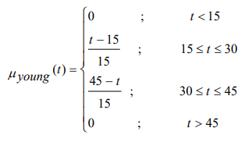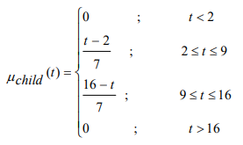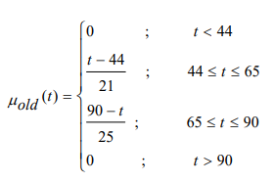

The membership function for TLC is separated into three sections, i.e., high, medium and low. The ranges of low medium and high are given below.

**(B): Membership function for TLC**

* 3500-4000 Low
* 3900-11000 Medium
* 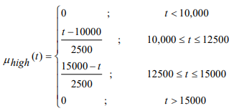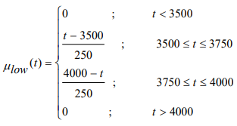10,000-15,000 High

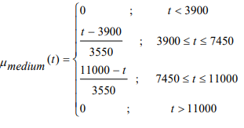

SGOT is the third input variable. The membership function for SGOT is splitted into three sections, i.e., high, medium and low. The ranges of low, medium and high are mentioned below.

**(C): Membership function for SGOT**

* 0-40 Low
* 35-50 Medium
* 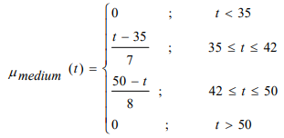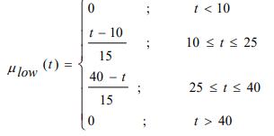45-55 High

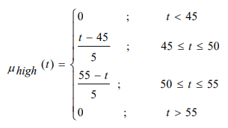

The membership function for platelets is separated into three sections, i.e., high, medium and low. The range of low is 3500-150000, the range of medium is from 140000-450000 and high ranges from 440000-470000.

**(D): Membership function for Platelets Count**

* 3500-1,50,000 Low
* 1,40,000-4,50,000 Medium
* 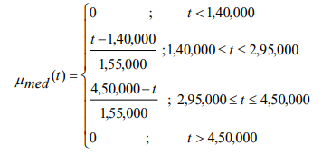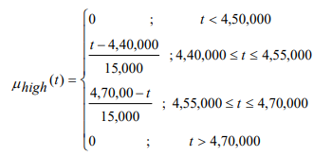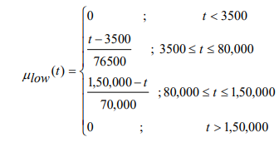4,40,000-4,70,000 High

Blood pressure is the fifth and last input variable. The membership function for BP is separated into three sections, i.e., low, medium and high. The ranges of low medium and high are mentioned below.

**(E): Membership function for Blood Pressure**

* 120-134 Low
* 127-161 Medium
* 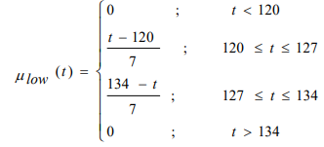154-172 High

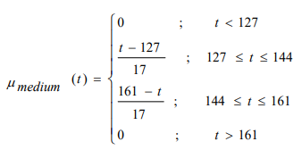

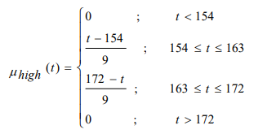

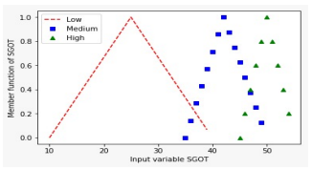**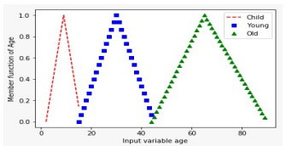GRAPH OF MEMBERSHIP FUNCTIONS**

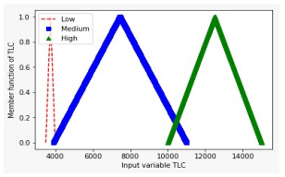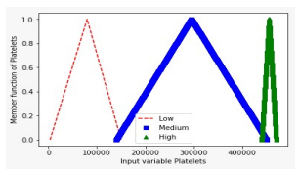 **Fig 3.1 Graph of function of $μ$ child, Fig 3.2 Graph of function of $μ$ low,**

$μ$**young and $μ$ old $μ$ medium and $μ$ high**

**Fig 3.3 Graph of function of $μ$ low, Fig 3.4 Graph of function of $μ$ low,**

$μ$**medium and $μ$ high $μ$ medium and $μ$ high**

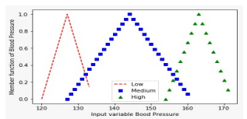

**Fig 3.5 Graph of function of $μ$ low,**

$μ$**medium and $μ$ high**

**3.2.1.3 FUZZY MEMBERSHIP VALUES OF LINGUISTIC VARIABLES:**

After fuzzifying the data, we obtain the fuzzy sets for each factor which is tabulated below:

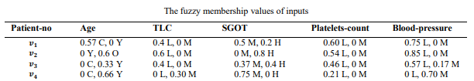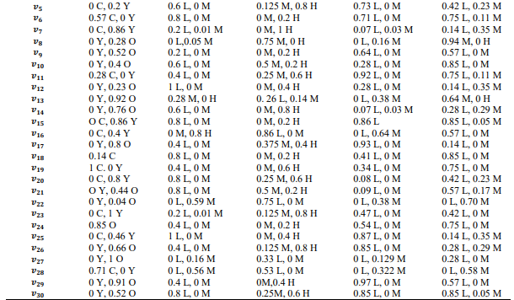**Table 1.1: The fuzzy membership values of inputs**

**3.2.2 TRANSFORMATION FUZZY SETS INTO SOFT SETS:**

Next step is to transform fuzzy sets into soft sets. Since the soft sets are a generalisation of fuzzy sets so by using the fuzzified values, the parameter sets are made by applying the definition of α-cut sets. Membership function gives the parametric sets.

Parameter sets provide the numerical costs so that soft set theory is applied to the data.

**3.2.2.1 SOFT SETTING FROM THR FUZZIFIED DATA:**

Soft sets for the child age, obtained from the fuzzified data.

**FOR CHILD AGE:**

Let V denotes the group of patients and E is defined as the set of parameters. The set of a parameter is different for each part of the input variable.

𝑉 = {𝑣1, 𝑣2, 𝑣3, … ,30},

𝐸 = {0, 0.25, 0.5, 0.75, 1}

($F_{C,Age}$, 𝐸) = {0 = {𝑣1, 𝑣3, 𝑣4, 𝑣5, 𝑣6, 𝑣7, 𝑣11, 𝑣15, 𝑣16, 𝑣18, 𝑣19, 𝑣20, 𝑣23, 𝑣25, 𝑣28},

0.25= {𝑣1, 𝑣6, 𝑣11, 𝑣19, 𝑣28},

0.5= {𝑣1, 𝑣6, 𝑣19, 𝑣28},

0.75= {𝑣19, 𝑣28},

1={𝑣19}}

**FOR LOW TLC**

𝐸 = {0.2, 0.4, 0.6, 0.8, 1},

($F_{L,TLC}$, 𝐸) = {0.2 = {𝑣1, 𝑣2, 𝑣3, 𝑣5, 𝑣6, 𝑣7, 𝑣9, 𝑣10, 𝑣11 𝑣12, 𝑣14, 𝑣15, 𝑣17, 𝑣18, 𝑣19, 𝑣20, 𝑣21, 𝑣23, 𝑣24, 𝑣25, 𝑣26, 𝑣29, 𝑣30},

0.4 = {𝑣1, 𝑣2, 𝑣3, 𝑣5, 𝑣6, 𝑣10, 𝑣11, 𝑣12, 𝑣14, 𝑣15, 𝑣17, 𝑣18, 𝑣19, 𝑣20, 𝑣21, 𝑣24, 𝑣25, 𝑣26, 𝑣29, 𝑣30},

0.6 = {𝑣2, 𝑣5, 𝑣6, 𝑣10, 𝑣12, 𝑣14, 𝑣15, 𝑣18, 𝑣20, 𝑣21, 𝑣25, 𝑣30},

0.8 = {𝑣6, 𝑣12, 𝑣15, 𝑣18, 𝑣20, 𝑣21, 𝑣25}

1= {𝑣12, 𝑣25}}

**FOR MEDIUM SGOT**

𝐸 = {0, 0.25, 0.5, 0.75, 1}

($F_{M,SGOT}$, 𝐸) = {0 = {𝑣1, 𝑣2, 𝑣3, …, 𝑣30},

0.25= {𝑣1, 𝑣3, 𝑣4, 𝑣8, 𝑣10, 𝑣11, 𝑣17, 𝑣20, 𝑣21, 𝑣30},

0.5= {𝑣1, 𝑣4, 𝑣8, 𝑣10, 𝑣21},

0.75= {𝑣4, 𝑣8},

1=∅}

**FOR LOW PLATELET COUNT**

𝐸 = {0.2, 0.55, 0.7, 0.85, 1},

($F_{L,PC}$, 𝐸) = {0.2 = {𝑣1, 𝑣2, 𝑣3, 𝑣4, 𝑣5, 𝑣6, 𝑣9, 𝑣10, 𝑣11, 𝑣12, 𝑣15, 𝑣17, 𝑣18, 𝑣19, 𝑣23, 𝑣24, 𝑣25, 𝑣26, 𝑣29, 𝑣30},

0.55 = {𝑣1, 𝑣2, 𝑣5, 𝑣6, 𝑣9, 𝑣11, 𝑣15, 𝑣17, 𝑣24, 𝑣25, 𝑣26, 𝑣29, 𝑣30},

0.7 = {𝑣5, 𝑣6, 𝑣11, 𝑣15, 𝑣17, 𝑣25, 𝑣26, 𝑣29, 𝑣30},

0.85 = {𝑣11, 𝑣15, 𝑣17, 𝑣25, 𝑣26, 𝑣29, 𝑣30},

𝐼 = ∅},

**FOR LOW BLOOD PRESSURE**

𝐸 = {0, 0.25, 0.5, 0.75, 1}

($F_{L,BP}$, 𝐸) = {0 = {𝑣1, 𝑣2, 𝑣3, 𝑣4, 𝑣5, 𝑣6, 𝑣7, 𝑣9, 𝑣10, 𝑣11, 𝑣12, 𝑣14, 𝑣15, 𝑣16, 𝑣17, 𝑣18, 𝑣19, 𝑣20, 𝑣21, 𝑣22, 𝑣23, 𝑣24, 𝑣25, 𝑣26, 𝑣27, 𝑣28, 𝑣29, 𝑣30},

0.2 = {𝑣1, 𝑣2, 𝑣3, 𝑣5, 𝑣6, 𝑣9, 𝑣10, 𝑣11, 𝑣14, 𝑣15, 𝑣16, 𝑣18, 𝑣19, 𝑣20𝑣21, 𝑣23, 𝑣24, 𝑣26, 𝑣27, 𝑣29, 𝑣30},

0.5 = {𝑣1, 𝑣2, 𝑣3, 𝑣6, 𝑣9, 𝑣10, 𝑣11, 𝑣15, 𝑣16, 𝑣18, 𝑣19, 𝑣21, 𝑣24, 𝑣29, 𝑣30},

0.75 = {𝑣1, 𝑣2, 𝑣6, 𝑣10, 𝑣11, 𝑣15, 𝑣18, 𝑣19, 𝑣24, 𝑣30},

𝐼 = ∅},

Similarly, the soft sets for each linguistic variables of various factors can be found. Totally 35 sets are obtained. Since some sets are of no value i.e., the empty sets are omitted.

**3.2.3 OBTAINING SOFT RULES:**

Next step is to obtain soft rules by using the soft sets of the previous step. With the help of logic operator, ‘AND’ operator the soft rules are obtained. By using soft rules, it is observed that which patient comes under which rule.

Taking the combinations of all the factors (Age, TLC, etc.,) at various severity level (parameter E). Ignoring all the combination with null sets. Some of the rules are discussed

**Rule1:**

**($F_{O,Age}$, 0.4) $⋀$ ($F_{L,TLC}$, 0.4) $⋀$ ($F_{H,SGOT}$, 0.6) $⋀$ ($F_{L,PC}$, 0.75) $⋀$ ($F_{L,BP}$, 0.25)**

The above rule is that for old age, low TLC, high SGOT, low Platelet count, low Blood pressure with severity levels 0.4, 0.4, 0.6, 0.75 and 0.25 respectively.

Patients who are under Rule1:**{“v26”, “v30”}**

**Rule2:**

**($F_{C,Age}$, 0.25) $⋀$ ($F_{L,TLC}$, 0.2) $⋀$ ($F_{H,SGOT}$, 0.2) $⋀$ ($F_{L,PC}$, 0.25) $⋀$ ($F_{L,BP}$, 0.5)**

Patients who are under Rule2:**{“v1”, “v6”, “v11”, “v19”}**

**Rule3:**

**($F_{Y,Age}$, 0.6) $⋀$ ($F_{L,TLC}$, 0.2) $⋀$ ($F_{H,SGOT}$, 0.2) $⋀$ ($F_{L,PC}$, 0.25) $⋀$ ($F_{L,BP}$, 0.5)**

**Rule4:**

**($F_{O,Age}$, 0.6) $⋀$ ($F_{L,TLC}$, 0.2) $⋀$ ($F_{H,SGOT}$, 0.2) $⋀$ ($F_{L,PC}$, 0.25) $⋀$ ($F_{L,BP}$, 0.5)**

**Rule5:**

**($F_{C,Age}$, 0.25) $⋀$ ($F_{L,TLC}$, 0.2) $⋀$ ($F_{M,SGOT}$, 0.25) $⋀$ ($F_{L,PC}$, 0.25) $⋀$ ($F_{L,BP}$, 0.5)**

**Rule6:**

**($F_{O,Age}$, 0.6) $⋀$ ($F_{L,TLC}$, 0.2) $⋀$ ($F_{H,SGOT}$, 0.2) $⋀$ ($F_{L,PC}$, 0.25) $⋀$ ($F_{L,BP}$, 0.25)**

**Rule7:**

**($F_{O,Age}$, 0.2) $⋀$ ($F_{L,TLC}$, 0.2) $⋀$ ($F_{H,SGOT}$, 0.6) $⋀$ ($F_{L,PC}$, 0.25) $⋀$ ($F_{L,BP}$, 0.5)**

**Rule8:**

**($F_{O,Age}$, 0.6) $⋀$ ($F_{L,TLC}$, 0.2) $⋀$ ($F_{H,SGOT}$, 0.6) $⋀$ ($F_{L,PC}$, 0.5) $⋀$ ($F_{L,BP}$, 0.25)**

**Rule9:**

**($F_{O,Age}$, 0.2) $⋀$ ($F_{L,TLC}$, 0.2) $⋀$ ($F_{M,SGOT}$, 0.25) $⋀$ ($F_{L,PC}$, 0.25) $⋀$ ($F_{L,BP}$, 0.25)**

**Rule10:**

**($F_{Y,Age}$, 0.2) $⋀$ ($F_{L,TLC}$, 0.2) $⋀$ ($F_{H,SGOT}$, 0.2) $⋀$ ($F_{L,PC}$, 0.25) $⋀$ ($F_{L,BP}$, 0.5)**

**Rule11:**

**($F_{O,Age}$, 0.2) $⋀$ ($F_{L,TLC}$, 0.2) $⋀$ ($F_{H,SGOT}$, 0.2) $⋀$ ($F_{L,PC}$, 0.25) $⋀$ ($F_{L,BP}$, 0.5)**

**Rule12:**

**($F_{C,Age}$, 0.25) $⋀$ ($F_{L,TLC}$, 0.2) $⋀$ ($F_{M,SGOT}$, 0.5) $⋀$ ($F_{L,PC}$, 0.25) $⋀$ ($F_{L,BP}$, 0.5)**

**Rule13:**

**($F_{O,Age}$, 0.4) $⋀$ ($F_{L,TLC}$, 0.2) $⋀$ ($F_{H,SGOT}$, 0.2) $⋀$ ($F_{L,PC}$, 0.25) $⋀$ ($F_{L,BP}$, 0.75)**

**Rule14:**

**($F_{O,Age}$, 0.2) $⋀$ ($F_{L,TLC}$, 0.8) $⋀$ ($F_{H,SGOT}$, 0.2) $⋀$ ($F_{L,PC}$, 0.25) $⋀$ ($F_{L,BP}$, 0.25)**

**Rule15:**

**($F_{Y,Age}$, 0.6) $⋀$ ($F_{L,TLC}$, 0.2) $⋀$ ($F_{H,SGOT}$, 0.2) $⋀$ ($F_{L,PC}$, 0.25) $⋀$ ($F_{L,BP}$, 0.25)**

**Rule16:**

**($F_{Y,Age}$, 0.2) $⋀$ ($F_{L,TLC}$, 0.2) $⋀$ ($F_{H,SGOT}$, 0.6) $⋀$ ($F_{L,PC}$, 0.25) $⋀$ ($F_{L,BP}$, 0.25)**

**Rule17:**

**($F_{C,Age}$, 0.5) $⋀$ ($F_{L,TLC}$, 0.2) $⋀$ ($F_{H,SGOT}$, 0.2) $⋀$ ($F_{L,PC}$, 0.25) $⋀$ ($F_{L,BP}$, 0.25)**

Similarly, some of the other rules can be framed.

**3.2.4 ANALYSIS OF SOFT RULES:**

**3.2.4.1 RISK FACTOR CALCULATION:**

Risk Percentage is given by

$$risk percentage(R)=\frac{number of patients affected with dengue fever from the rule}{total number of patients from the rule} ×100$$

For rule 1: the risk percentage of dengue fever patients at prescribed severity level is

$$R= \frac{2}{2} ×100=100\%$$

By this calculation, the patients whose inputs of Age, TLC, SGOT, Platelets count and Blood pressure are expedient to rule 1 have 100% risk of dengue fever.

For rule 2: the risk percentage of dengue fever patients at prescribed severity level is

$$R= \frac{2}{4} ×100=50\%$$

There are 2 patients who have attributes of rule 2. Hence the risk percentage for the rule 2 is 50%

For rule 10: the risk percentage of dengue fever patients at prescribed severity level is

$$R= \frac{1}{4} ×100=25\%$$

For rule 16: the risk percentage of dengue fever patients at prescribed severity level is

$$R= \frac{0}{2} ×100=0\%$$

For rule 17: the risk percentage of dengue fever patients at prescribed severity level is

$$R= \frac{2}{3} ×100=67\%$$

The risk of rule 17 is 67%. Therefore, the patients with the values of Age, TLC, SGOT, Platelets count and Blood pressure convenient to rule 17 have the 67% risk of dengue fever.

The table below shows the risk percentage of patients under the above stated rules.

**Table 1.2 Rules of soft sets and their risk respective risk percentage**

|  |  |  |
| --- | --- | --- |
| **Rule** | **Criteria** | **Risk percentage** |
| 1 | **($F_{O,Age}$, 0.4) $⋀$ ($F_{L,TLC}$, 0.4) $⋀$ ($F_{H,SGOT}$, 0.6) $⋀$ ($F_{L,PC}$, 0.75) $⋀$ ($F_{L,BP}$, 0.25)** | 100% |
| 2 | **($F_{C,Age}$, 0.25) $⋀$ ($F_{L,TLC}$, 0.2) $⋀$ ($F_{H,SGOT}$, 0.2) $⋀$ ($F_{L,PC}$, 0.25) $⋀$ ($F_{L,BP}$, 0.5)** | 50% |
| 3 | **($F_{Y,Age}$, 0.6) $⋀$ ($F_{L,TLC}$, 0.2) $⋀$ ($F_{H,SGOT}$, 0.2) $⋀$ ($F_{L,PC}$, 0.25) $⋀$ ($F_{L,BP}$, 0.5)** | 50% |
| 4 | **($F_{O,Age}$, 0.6) $⋀$ ($F_{L,TLC}$, 0.2) $⋀$ ($F_{H,SGOT}$, 0.2) $⋀$ ($F_{L,PC}$, 0.25) $⋀$ ($F_{L,BP}$, 0.5)** | 100% |
| 5 | **($F_{C,Age}$, 0.25) $⋀$ ($F_{L,TLC}$, 0.2) $⋀$ ($F_{M,SGOT}$, 0.25) $⋀$ ($F_{L,PC}$, 0.25) $⋀$ ($F_{L,BP}$, 0.5)** | 100% |
| 6 | **($F_{O,Age}$, 0.6) $⋀$ ($F_{L,TLC}$, 0.2) $⋀$ ($F_{H,SGOT}$, 0.2) $⋀$ ($F_{L,PC}$, 0.25) $⋀$ ($F_{L,BP}$, 0.25)** | 100% |
| 7 | **($F_{O,Age}$, 0.2) $⋀$ ($F_{L,TLC}$, 0.2) $⋀$ ($F_{H,SGOT}$, 0.6) $⋀$ ($F_{L,PC}$, 0.25) $⋀$ ($F_{L,BP}$, 0.5)** | 100% |
| 8 | **($F_{O,Age}$, 0.6) $⋀$ ($F_{L,TLC}$, 0.2) $⋀$ ($F_{H,SGOT}$, 0.6) $⋀$ ($F_{L,PC}$, 0.5) $⋀$ ($F_{L,BP}$, 0.25)** | 100% |
| 9 | **($F_{O,Age}$, 0.2) $⋀$ ($F_{L,TLC}$, 0.2) $⋀$ ($F_{M,SGOT}$, 0.25) $⋀$ ($F_{L,PC}$, 0.25) $⋀$ ($F_{L,BP}$,0.25)** | 100% |
| 10 | **($F_{Y,Age}$, 0.2) $⋀$ ($F_{L,TLC}$, 0.2) $⋀$ ($F_{H,SGOT}$, 0.2) $⋀$ ($F_{L,PC}$, 0.25) $⋀$ ($F_{L,BP}$, 0.5)** | 25% |
| 11 | **($F_{O,Age}$, 0.2) $⋀$ ($F_{L,TLC}$, 0.2) $⋀$ ($F_{H,SGOT}$, 0.2) $⋀$ ($F_{L,PC}$, 0.25) $⋀$ ($F_{L,BP}$, 0.5)** | 100% |
| 12 | **($F_{C,Age}$, 0.25) $⋀$ ($F_{L,TLC}$, 0.2) $⋀$ ($F_{M,SGOT}$, 0.5) $⋀$ ($F_{L,PC}$, 0.25) $⋀$ ($F_{L,BP}$, 0.5)** | 100% |
| 13 | **($F_{O,Age}$, 0.4) $⋀$ ($F_{L,TLC}$, 0.2) $⋀$ ($F_{H,SGOT}$, 0.2) $⋀$ ($F_{L,PC}$, 0.25) $⋀$ ($F_{L,BP}$, 0.75)** | 100% |
| 14 | **($F_{O,Age}$, 0.2) $⋀$ ($F_{L,TLC}$, 0.8) $⋀$ ($F_{H,SGOT}$, 0.2) $⋀$ ($F_{L,PC}$, 0.25) $⋀$ ($F_{L,BP}$, 0.25)** | 100% |
| 15 | **($F_{Y,Age}$, 0.6) $⋀$ ($F_{L,TLC}$, 0.2) $⋀$ ($F_{H,SGOT}$, 0.2) $⋀$ ($F_{L,PC}$, 0.25) $⋀$ ($F_{L,BP}$, 0.25)** | 50% |
| 16 | **($F_{Y,Age}$, 0.2) $⋀$ ($F_{L,TLC}$, 0.2) $⋀$ ($F_{H,SGOT}$, 0.6) $⋀$ ($F_{L,PC}$, 0.25) $⋀$ ($F_{L,BP}$, 0.25)** | 0% |
| 17 | **($F_{C,Age}$, 0.5) $⋀$ ($F_{L,TLC}$, 0.2) $⋀$ ($F_{H,SGOT}$, 0.2) $⋀$ ($F_{L,PC}$, 0.25) $⋀$ ($F_{L,BP}$, 0.25)** | 67% |

**CHAPTER V**

**SUMMARY AND CONCLUSION**

In this study, an expert soft sets system (SES) based on soft sets and fuzzy set theory to diagnose the dengue fever is used. A real utilization of soft set theory in the field of medical science is a soft expert system which can be used to diagnose the dengue fever.

Here, fuzzy set theory and determination of fuzzy membership function to fuzzify the data is considered. An algorithm of parameters reduction of soft sets is also used to reduce the soft sets.

The dataset contains the diagnosis of 30 dengue fever patients which includes the essential factors as Age of the patients, TIC count, SGOT level, Platelet count and Blood pressure level, with the help of these factors as input variables, the interest is to find the risk of dengue with severity of factors. As per experts and research-based level, person with an old Age, low TLC, high SGOT, low Platelets Count and low Blood pressure must have dengue. As per this criterion, from the datasets it is seen that 17 patients are affected with dengue and 13 without dengue.

The exact percentage risk of dengue fever that will help an expert or practitioner to treat the patient accordingly at its precise severity level is discussed

The patient with high percentage risk of 100% will have potential for dengue fever is also discussed through soft set rule.

Our objective is to help the doctors in examining the patient health conditions and

diagnosing the disease severity. In this study if risk percentage is greater than 50%, then the study recommends the doctors in examining patient health conditions and diagnosing the dengue severity.

**REFERENCE**

1. Boullart, L, Krijgsman, A, Vingerhoeds, R. A1992, ‘editors Applications of Artificial Intelligence in process control program press’.
2. Chen, D, Tsang, E, C, C, Yeung, D, S, Wang, X, ‘the parameterization reduction of soft sets and its applications’, *Comput. Math.* Appl. 49 (2005) 757-763.
3. Fariha Iftikhar, Faiza Ghulam Nabi’s 2018, ‘A distinct approach to diagnose dengue fever with the help of soft set theory’.
4. James, J, Buckleys 2006, *Fuzzy probability and statistics,* Springer.
5. Maji, P. K, Biswas, R, Roy, A. R 2003,’Soft set theory’, *Comput. Math*. Appl. 45, pp. 555-562.
6. Molodtsov, D. A 1999, ‘Soft set theory- first results’, *Comput. Math.* Appl. 37, pp.19-31.
7. Pabbi, V 2015, ‘Fuzzy Expert System for Medical Diagnosis’*. IJSRP,* vol. 5.
8. Sharam, P, Singh, DBV, Bandil M. K, and Mishra, N 2013, ‘Decision Support System for Malaria and Dengue Diagnosis’, *International Journal of Information and Computational Technology*, vol.3 pp. 633-640.
9. Zadeh, L. A 1965, ‘Fuzzy sets’, *Inform. and Control,* vol.8, pp. 338-353
10. Zimmermann, H.J 2011, *Fuzzy Set Theory—And Its Applications,* Springer Science & Business Media, Berlin.